Alignment of LeuT and BetP transporters.

Beside being both sodium symporter proteins, BetP and LeuT also share the inverted 5TM repeat topology. In the HOMEP2012 database they were identified as belonging to the same structural family of proteins. They constitute an excellent example of two trans-membrane proteins belonging to the same structural and functional family while hardly sharing any similarity at the sequence level. While they share the same topology, terminal helices are shifted relative to the repeats, posing an additional challenge to the alignments. LeuT has 2 helices after the repeats, while BetP has them before the repeats.

We compared the standard pair-wise alignments (Fig 1, left) with the one using anchors, derived from the alignment of two multiple sequences alignments (Fig 1, right), created with the AlignMe server. For the applied workflow of deriving the anchors see Fig 7. The alignments show clear differences, indicating that for these highly challenging cases a simple pairwise alignment will not suffice to get a proper alignment that reflects the structural alignment.

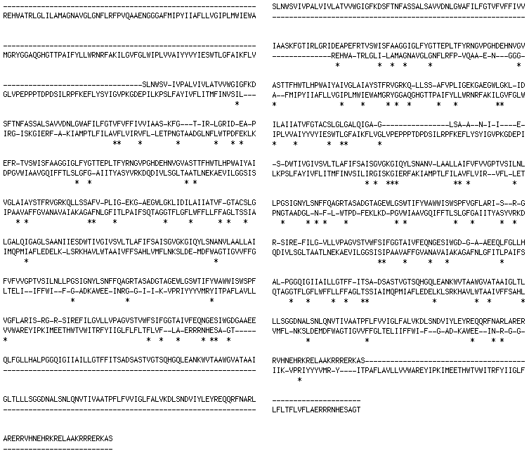

Fig 1: Pairwise alignment of BetP (top sequence) with LeuT (lower sequence). Left: basic pairwise alignment. Right: with anchors.

The improvement due to the usage of anchors becomes more obvious when looking at the alignment of the profiles. Figure 2 shows two profiles for the alignment without anchors, Figure 3 an alignment of profiles when using the anchors.

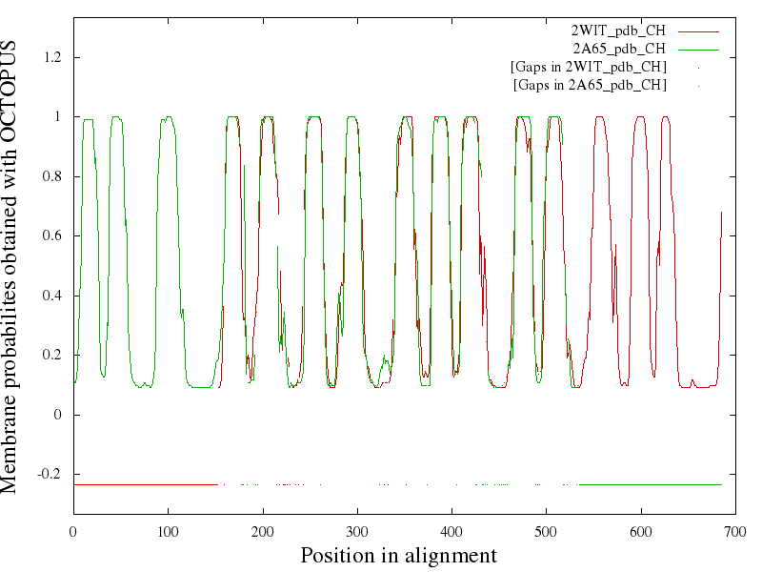
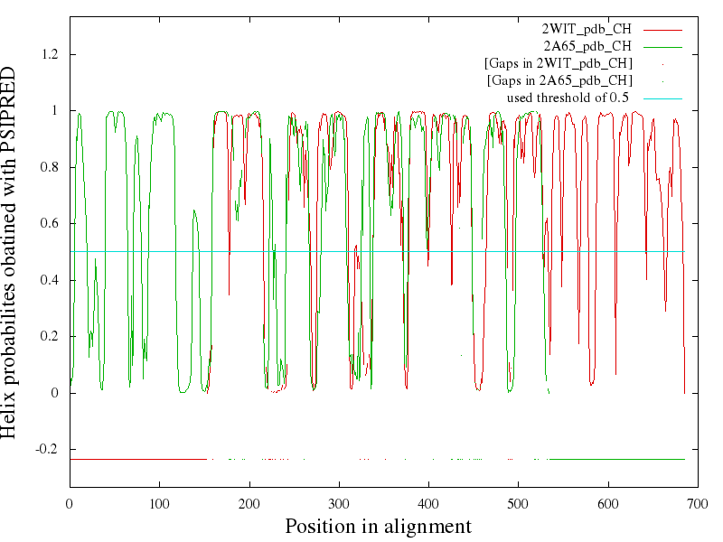

Fig 2: Аlignment of BetP (red) and LeuT (green) profiles WITHOUT anchors. Top: transmembrane predictions, bottom: helix secondary structure prediction.

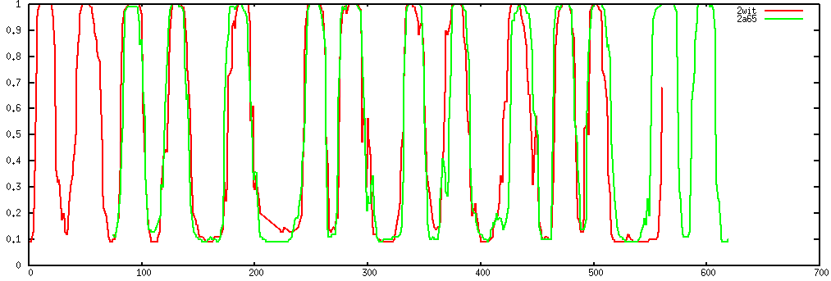
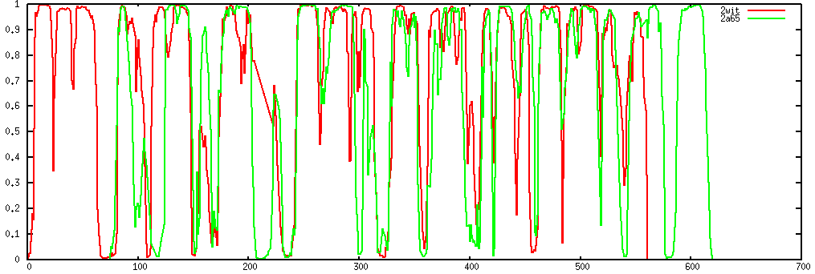

Fig B.2: Alignment of BetP (red) and LeuT (green) using anchors, derived from alignment of Muscle-MSAs. Top: alignment of Octopus transmembrane prediction. Other three: alignment of Psipred secondary structure predictions (helix, sheet, coil).

The alignments differ significantly and seem greatly improved due to the anchors.

The anchors were derived as follows: for both LeuT and BetP homologous sequences were collected using PSI-BLAST and a multiple sequence alignment was created using T-COFFEE for both individually [HOMEP]. The two MSAs were used as input for the AlignMe server PP mode using default values. The server creates an averaged hydropathy profile for each of the MSAs and aligns them (Fig. 5). In the second step the averaged profile is mapped back on the initial query sequences (Fig. 4).

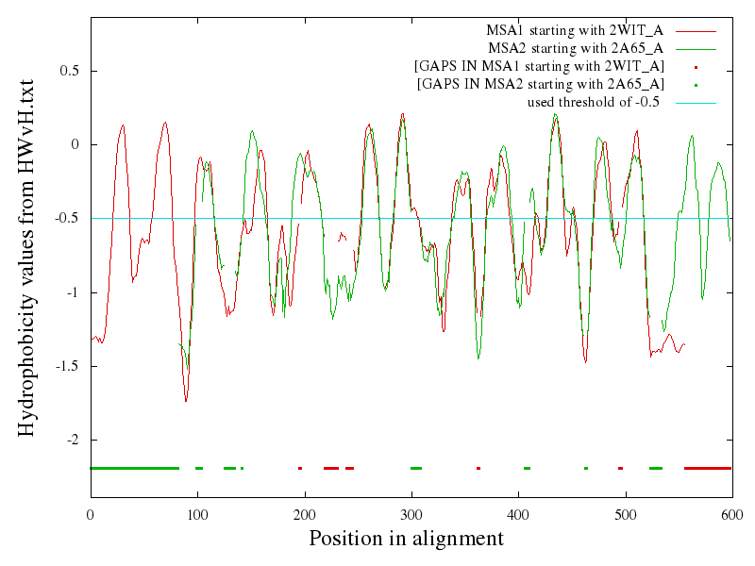
Fig B.1: the aligned profiles of the MSAs of 2WIT (BetP) and 2A65 (LeuT)

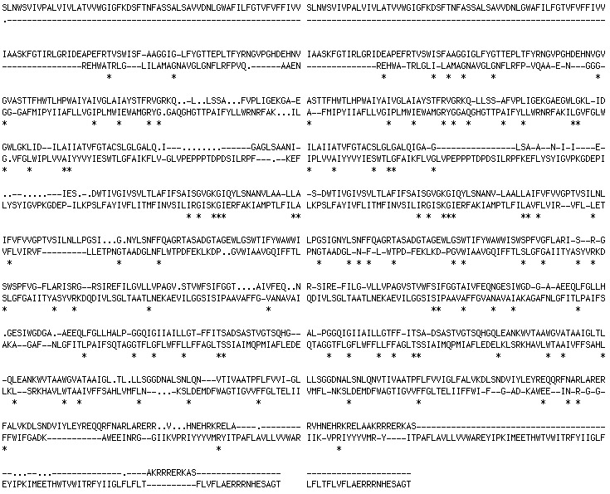
Fig B.3: Left: the alignment of the MSAs of 2WIT (BetP) and 2A65 (LeuT), mapped back on their sequences. Right: alignment using anchors.

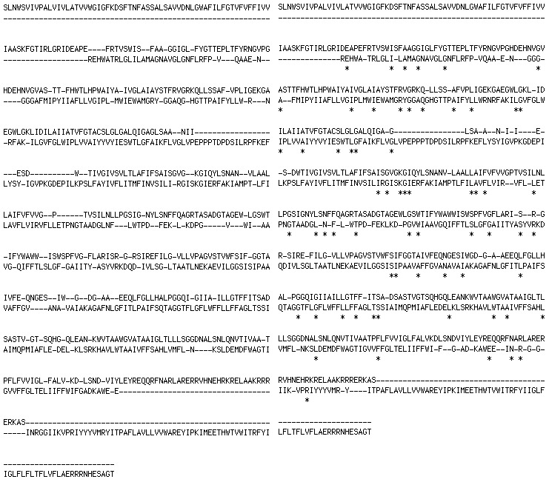
Fig B:4: Left: Ska structural alignment. Right: anchored alignment.

Below there is a list of the anchors used for the final alignment. It was selected from the alignment of MSAs as identical positions, denoted as ‘*’ in Fig. 4 (left). Note that these are residue IDs, not positions from Fig 5.
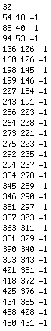

 |  |  |  | -1 | -1 | -1
 | 0 |  |  | -1 | -1 | -1
 |  |  |  | -1 | -1 | -1
 |  |  |  | -1 | -1 | -1
-1 | -1 | -1 | -1 | 0
-1 | -1 | -1 | -1 |  |  | 0
-1 | -1 | -1 | -1

Fig 6: a sketch of a small anchor matrix. The weight of the anchor is set arbitrarily to 1 in this example. The green zero indicates the anchor position.

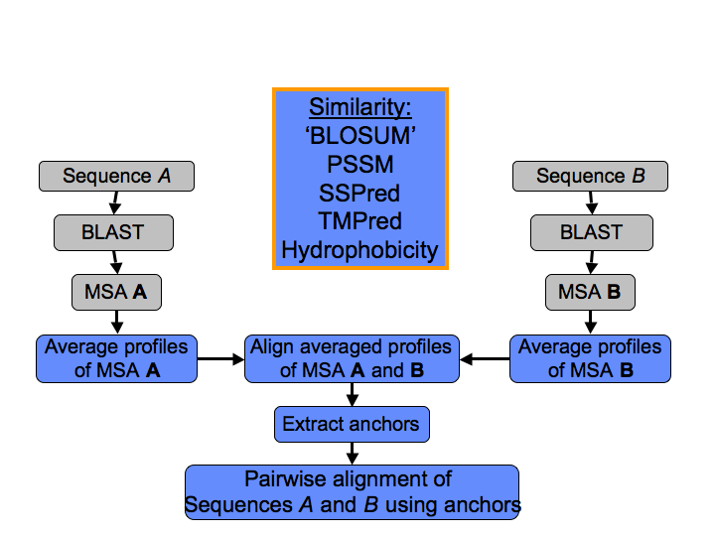

Fig 7: The workflow of the alignment strategy for proteins sharing hardly any similarity on a sequence level.

